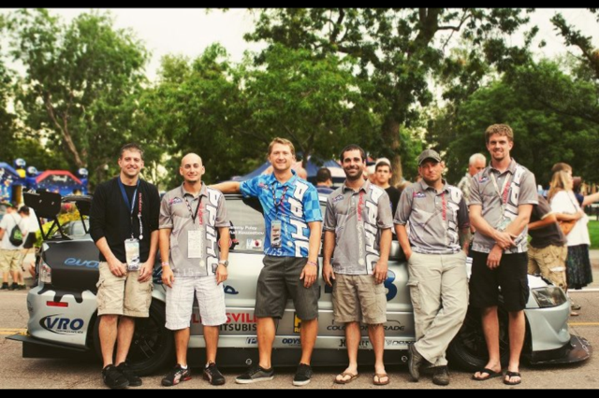Jeremy R. Foley
Pictured 2nd from left

Overall Accolades -- 2005-2014
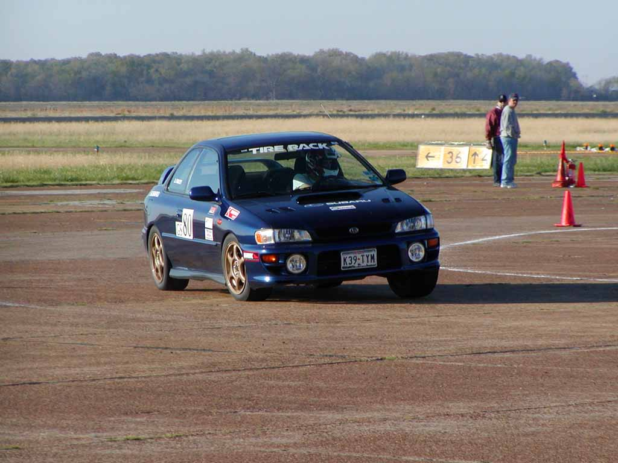
2005 Season

G-Stock #80 – 2001 Subaru Impreza 2.5 RS

Tire Rack SCCA Walnut Ridge National Tour
March 18-20, 2005
3rd Place / 7 in class

Tire Rack SCCA Houston National Tour April 1-3, 2005
2nd Place / 9 in class

2006 Season

Tire Rack SCCA Walnut Ridge, Arkansas National Tour -- April 1-2, 2006
3rd in Class / 13 in class

2006 Tour Houston, TX
Results Unknown

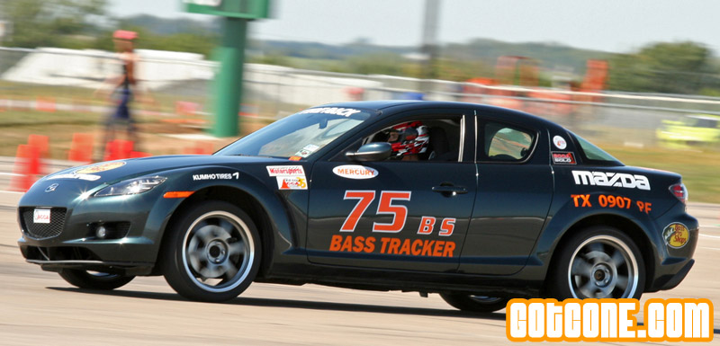
2007 Season

B- Stock #75 – 2004 Mazda RX-8

2007 Tire Rack SCCA Solo National Championships
11th Place / 35 in class
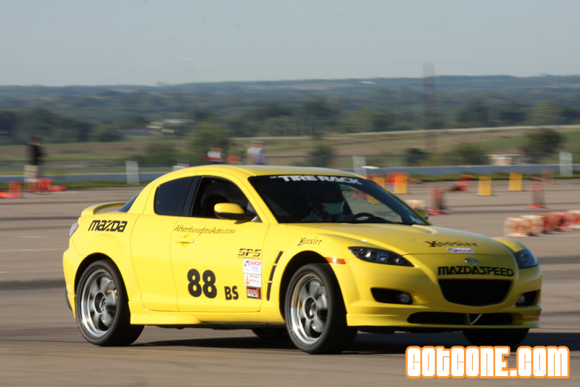
2008 Season
B- Stock #88 – 2004 Mazda RX-8

Tire Rack SCCA Ft. Worth National Tour -- May 3-4, 2008
1st Place / 7 in class
11th in Pax

Tire Rack SCCA Pro-Solo Newport, Arkansas -- April 12-13, 2008
2004 Corvette Z06 (1st time ever driving a corvette)
Super Stock
1st Place / 8 in class

2008 Tire Rack SCCA Solo National Championships
B-Stock RX-8
7th place – 35 in class
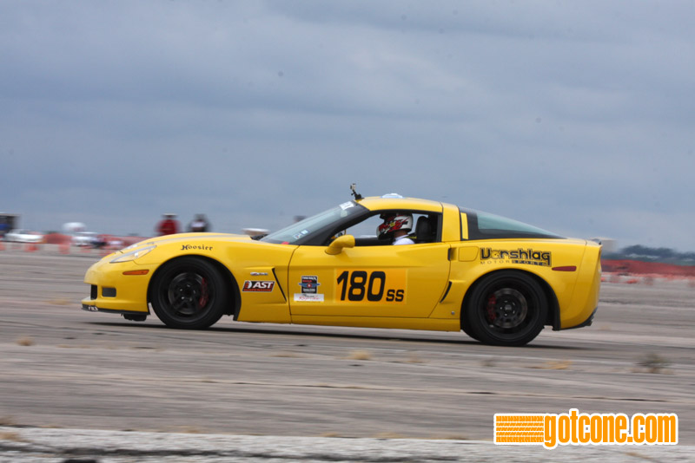

2009 Season

Super Stock 2008 Corvette Z06 #180

Tire Rack SCCA Houston National Tour -- April 4-5, 2009
3rd Place / 14 in class

Tire Rack SCCA Farmington National Tour -- May 16-17, 2009
CSP 1999 Mazda Miata
2nd Place / 13 in Class

Tire Rack SCCA Blytheville National Tour -- May 30-31, 2009
SS 2nd place / 14 in class

Tire Rack SCCA Blytheville National Tour #2 -- October 24-25, 2009
SS 2nd Place / 4 in class

Tire Rack SCCA Pro Solo Blytheville, AR -- June 6-7, 2009
SS 3rd Place / 11 in class

2009 Tire Rack National Solo Championships -- September 8-11, 2009
SS 10th on day one. Rain skewed results for day two.

2010 Season

Tire Rack SCCA 2010 Dixie National Tour March 13-14 2010
Super Stock – 2008 Corvette Z06
4th Place / 13 in class

Tire Rack SCCA 2010 Texas National Tour March 27-28 2010
1st Place / 13 in class
Top PAX

Tire Rack SCCA 2010 Blytheville Tour May,28-30, 2010
4th Place / 23 in class

Tire Rack SCCA 2010 Blytheville Tri State National Tour Oct 22=24, 2010
3rd Place / 7 in class

Tire Rack SCCA 2010 Blytheville ProSolo Jun 5-6, 2010
2nd place / 8 in class

2010 Tire Rack SCCA Solo Nationals September 7-10, 2010
10th Place / 62 in class

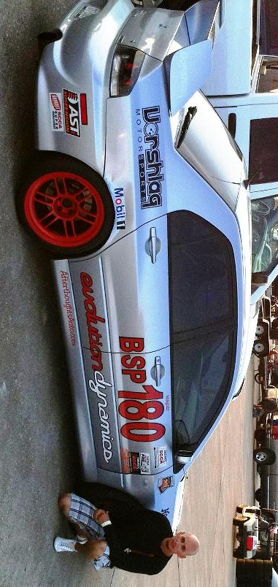Jeremy R. Foley

2011 Accolades

B Street Prepared Mitsubishi Evolution 9 SE
Primary Sponsors
Evolution Dynamics
Secondary Sponsors
Vorshlag Motorsports
AST USA
Afterthoughtsauto.com
National Events (only trophy positions bolded/underlined)
Tire Rack SCCA Pro-Solo

2011 Mineral Well Pro-Solo
Mineral Wells, TX 3/26-3/27
1st and 2nd in B Street Prepared (BSP) Bump Class (10 in class)
*Top PAX for the event

2011 Blytheville Pro-Solo
Blytheville, AR 4/30-5/1
7th and 11th in B Street Prepared (BSP) Bump Class (24 total in class)
*Fastest Right Side time, coned away top PAX and top time for class.

2011 Lincoln Pro-Solo(Spring Nationals)
Lincoln, NE 5/27-5/28
3rd in BSP (6 in class)
*2nd fastest right side time.

Pro-Solo cont.

Pro-Solo Finale
Lincoln, NE 8/27-8/28
3rd place (8 in class)
(Fastest time on left course)
4th in year end points (25 in Class)

Tire Rack SCCA Solo National Tour

Houston National Tour
Houston, TX 3/19-3/20
1st in F Prepared (FP)* (4 in class)
1st in X Prepared (XP) (7 in class)

Lincoln National Tour
Lincoln, NE 5/29-5/30
2nd Place BSP (7 in class)

Blytheville National Tour; Southern States Championship
Blytheville, AR 6/11-6/12
1st and 2nd in Street Mod (SM) (7 in class)

Tire Rack SCCA Solo National Championships
4th place out of 28th.

Tri State Challenge National Tour
Blytheville, AR 10/1-10/2
2nd in BSP (5 in class)
7th in PAX

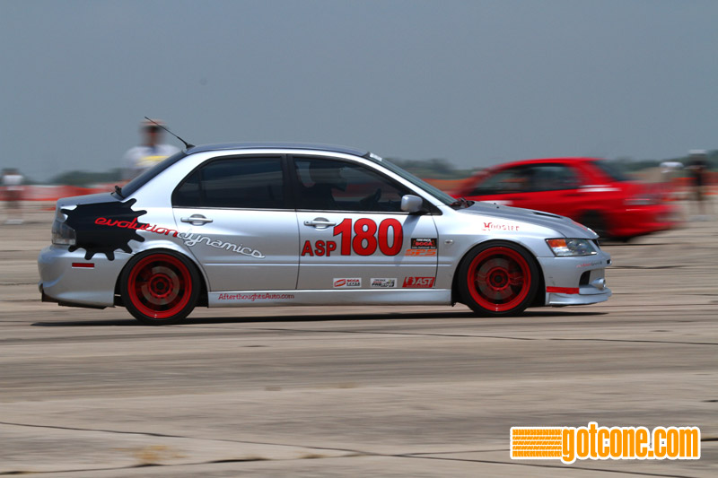Jeremy R. Foley
2012 Accolades
ASP - A Street Prepared Mitsubishi Evolution 9 SE

Primary Sponsors
Evolution Dynamics

Secondary Sponsors
Vorshlag Motorsports
AST USA
Afterthoughtsauto.com

National Events (only trophy positions bolded/underlined)

Tire Rack SCCA Solo National Tour

2012 Sun Belt National Tour March 16-18, 2012
1st Place ASP (5 in class)

2012 Lincoln National Solo Event May 27-28, 2012
3rd Place ASP (13 in class)

2012 Blytheville National Tour
Summer Nationals June 9-11, 2012
4th Place ASP (9 in class)

2012 Blytheville Tri State Solo Oct 27-28, 2012
1st Place A-Stock (5 in class)

*2011 BMW 1M (1st time ever driving car)

Tire Rack SCCA Pro-Solo

2012 Mineral Wells ProSolo
Round 2 April 21-22, 2012
2nd in A Street Prepared (ASP) Bump Class (11 in class)

2012 Lincoln ProSolo May 25-26, 2012
2nd in ASP (7 in class)

2012 Blytheville ProSolo June 7-9, 2012
3nd in A Street Prepared (ASP) Bump Class (17 in class)
*Fastest scratch time on left course.

Tire Rack SCCA Solo National Championships

2012 Solo Nationals Sept 4-7, 2012
Street Touring Roadster – STR
2006 MX-5
18th Place (51 Drivers)
*1st event after Pikes Peak Crash

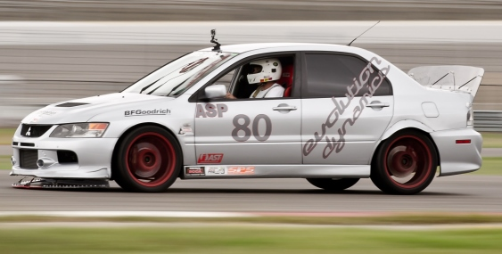
Jeremy R. Foley
2013 Accolades
ASP - A Street Prepared Mitsubishi Evolution 9 SE

Primary Sponsors
Evolution Dynamics

Secondary Sponsors
AST USA
Afterthoughtsauto.com

National Events (only trophy positions bolded/underlined)

Tire Rack SCCA Solo National Tour
2013 Sunbelt Championship Tour (College Station, TX)
March 23-24, 2013
4th in ASP (5 in class) *Tire Compound not suited for cold weather

2013 Lincoln Mid States Championship (Lincoln, NE)
May 26-27, 2013
4th in ASP (8 in class, 3 trophy positions) *3rd fastest time in class on day one.

Tire Rack SCCA Pro-Solo
2013 Mineral Wells ProSolo
Apr 13-14, 2013
Bump Class S1 2nd in class – (7 drivers)

2013 Lincoln ProSolo
May 23-25, 2013
Bump Class S1 2nd in class – (11 drivers)

Tire Rack SCCA Solo National Championships
September 2nd – 6th, 2013
5th in ASP (15 in class) *last minute entry on well used tires

2014
Took season off for family.

